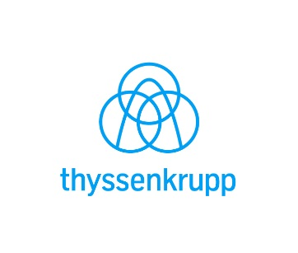MEDIA ALERT  
IQC SLIP-FORM CONSTRUCTION

Going Up: thyssenkrupp Elevator’s Innovation and Qualification Center Next to The Battery Atlanta Starting to Take Shape

On January 22, 2020, Brasfield & Gorrie began constructing the core of thyssenkrupp Elevator’s Innovation and Qualification Center (IQC), future home of the tallest elevator test tower in the Western Hemisphere and the crown jewel of thyssenkrupp Elevator’s new three-building North American headquarters next to The Battery Atlanta.

Utilizing a process known as slip-form construction, Brasfield & Gorrie is creating the framework for the IQC, building up at a pace of more than 7 seven feet per day. Working around the clock, the IQC will reach 100 feet in February (and be visible from both I-285 and I-75) and will reach its full height of more than 400 feet by April 2020.

The IQC is scheduled for completion by Summer 2021, with full move-in into the IQC and adjacent Corporate Headquarters (CHQ) expected by the end of 2021. In March 2019, thyssenkrupp Elevator’s shared-services team and other departments began moving into the Business Headquarters (BHQ) at nearby Pennant Park.

To view time-lapse video of the IQC construction and stay on top of its progress, click [here](http://www.thyssenkruppelevator.com/About-Us/atlanta-headquarters) or go to [www.thyssenkruppelevator.com/About-Us/atlanta-headquarters](http://www.thyssenkruppelevator.com/About-Us/atlanta-headquarters).

What is slip-form construction?

The popular European based system, commonly referred to as the core or skeleton of the building, is a moving formwork system that is set down on the foundation and involves the continuous pouring of concrete into a moving form 24 hours a day 7 days a week. Relatively rare in the U.S., this process was used in the creation of thyssenkrupp Elevator’s state-of-the-art 800-foot test tower in Rottweil, Germany.